RSRUnites

Project Title: RSRUnites
Project: College Community Posting Platform
Developed By: Chauhan Divyesh Kaushik
Enrollment No.: 234BCA009
Department of Computer Applications
Rofel BBA/BCA College, RSRU

Acknowledgement

I would like to express my profound gratitude to my project guide Prof. Tanvi Rana for their invaluable guidance, encouragement, and constant supervision throughout the development of the project titled RSRUnites ‒ a College Community Posting Platform. Their insightful suggestions and continuous motivation helped me overcome various challenges and gain a deeper understanding of project development and implementation.

I also extend my sincere thanks to the Head of Department and all the faculty members of BCA Department, RSRU for providing me with the necessary facilities, support, and environment that enabled me to complete this project successfully. Their lectures, mentoring, and knowledge-sharing sessions were instrumental in shaping my technical and analytical skills.

I would also like to acknowledge the support of my friends for their constant encouragement, feedback, and teamwork spirit. They contributed valuable ideas during discussions and helped me refine the user interface and functionality of the project.

Finally, I am deeply grateful to my family for their belief in my capabilities. It kept me focused and determined to complete this work to the best of my abilities.

This project has been a valuable learning experience that enhanced my understanding of real-world application development using HTML, CSS, JavaScript, PHP, and MySQL. It has given me a practical insight into teamwork, system design, and problem-solving in software projects.
Index

Sr. No. | Topic | Pg. No.
1. | Introduction  1.1 Project Profile ‒ Definition and Overview  1.2 Objectives | 3
2. | Software Requirement Specification  2.1 E-R Diagram  2.2 Data Flow Diagram  2.3 Data Dictionary | 4
3. | User Interface (Screenshots) | 9
4. | Bibliography / Webography | 12

1. Introduction

1.1 Project Profile ‒ Definition and Overview

The project titled RSRUnites is a college community posting platform designed to create a shared space for students and administrators of a college or university. It allows registered users to post images and captions that are visible to others once approved by an administrator. The project aims to build a digital community within the institution, enhancing communication and engagement among students and faculty.

The platform has two primary roles: the Admin and the User. Admins handle approvals for join requests, post moderation, and news updates. Users can register, verify their email, post content, and interact with the community after admin approval. This project uses HTML, CSS, JavaScript, PHP (XAMPP), and MySQL for its implementation.

1.2 Objectives

- To develop an online community platform for college/university students.
- To enable admin verification for user registration and post approvals.
- To allow users to post images with captions.
- To facilitate communication and engagement through a common community space.
- To implement secure authentication and role-based access.
- To provide an easy-to-use interface for both users and administrators.

2. Software Requirement Specification

2.1 E-R Diagram

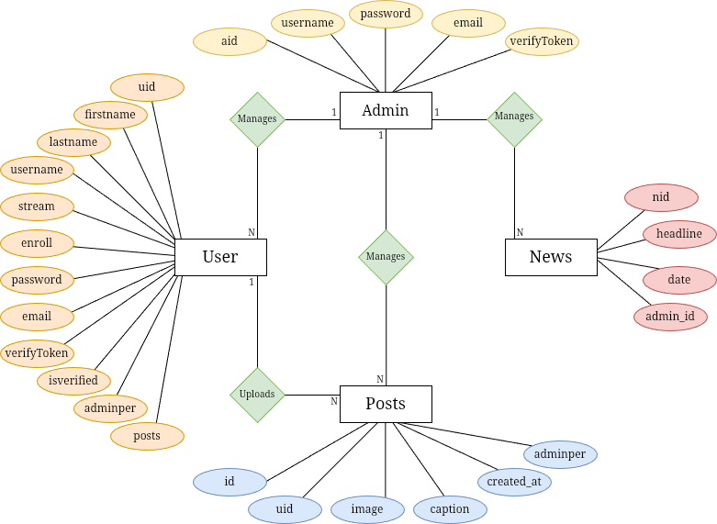

2.2 Data Flow Diagram

- Zero/Context Level DFD

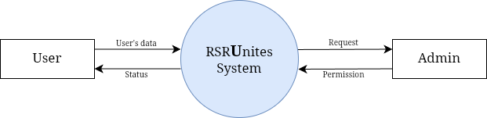

- 1st Level DFD

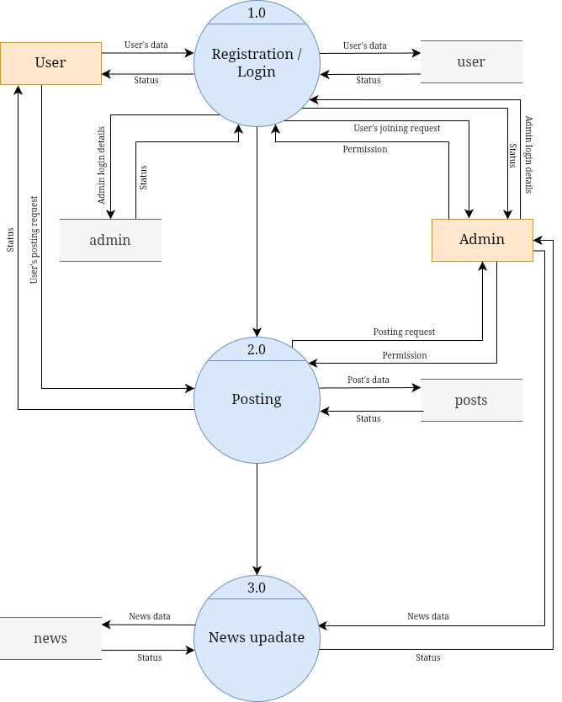

2.3 Data Dictionary

The database consists of four main tables:
- Admin: Stores admin credentials and verification tokens.
- User: Contains user registration details, email verification status, and approval info. Here user means the students.
- Posts: Maintains all post data including image path, caption, and approval status.
- News: Stores news updates added by admin to display on homepage.

- Admin Table

Column | Type | Constraints | Describe
aid | int | Primary key, Auto increment | Gives a unique integer id which represents the respective admin.
username | varchar | Not NULL | It's the username of the admin account.
password | varchar | Not NULL | Admin account’s password, used to login.
email | varchar | Not NULL | Everytime the admin tries to login an verification email is sent on this email address.
verifyToken | varchar | Default | The email contains this token used for verification. Everytime admin logins a new token is sent.

- User Table

Column | Type | Constraints | Describe
uid | int | Primary key, Auto increment | Gives a unique integer id which represents the respective user.
firstname | tinytext | Not NULL | First name of the user.
lastname | tinytext | Not NULL | Last name of the user.
username | varchar | Not NULL | It's the username of the user account.
stream | tinytext | Not NULL | The stream in which the student studies [BBA/BCA].
enroll | tinytext | Unique key | The enrollment number of the student.
password | varchar | Not NULL | User account’s password, used to login.
email | varchar | Not NULL | When a user registers an verification email is sent on this email address.
verifyToken | varchar | Default | The email contains this token used for verification.
isverified | tinyint | Default | When the email is verified, it's value is updated to 1, else NULL.
adminper | tinyint | Default | Admin’s permission to join the community.
posts | int | Default | Number of posts uploaded by the user in the community.

- Posts Table

Column | Type | Constraints | Describe
id | int | Primary key, Auto increment | Gives a unique integer id which represents the respective posts.
uid | int | Foreign key | Contains the ID of the user from the user table who uploaded the post.
image | varchar | Not null | Contains the image of the post.
caption | text | Default | Contains the caption of the post.
created_at | timestamp | Not NULL, Default | Contains the date and time, when the post was uploaded by the user (upload request).
adminper | tinyint | Default | Admin’s permission to upload the post in the community.

- News Table

Column | Type | Constraints | Describe
nid | int | Primary key, Auto increment | Gives a unique integer id which represents the respective news.
headline | text | Not NULL | Contains the news.
date | datetime | Default | Contains the date and time, when the news was uploaded.
admin_id | int | Foreign key | Contains the ID of the admin from the admin table who uploaded the news.

3. User Interface (Screenshots)

- Website intro images

 | 

- Index/Home Page

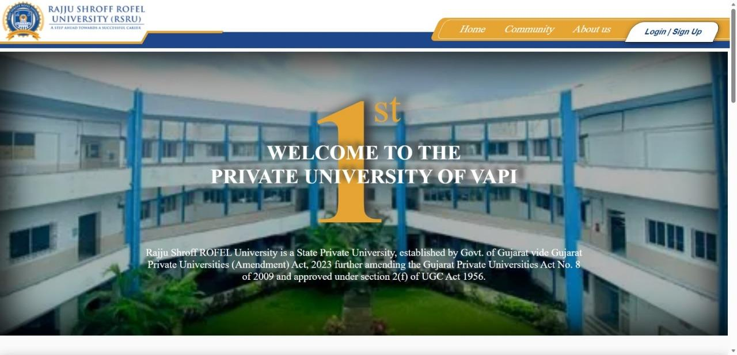 | 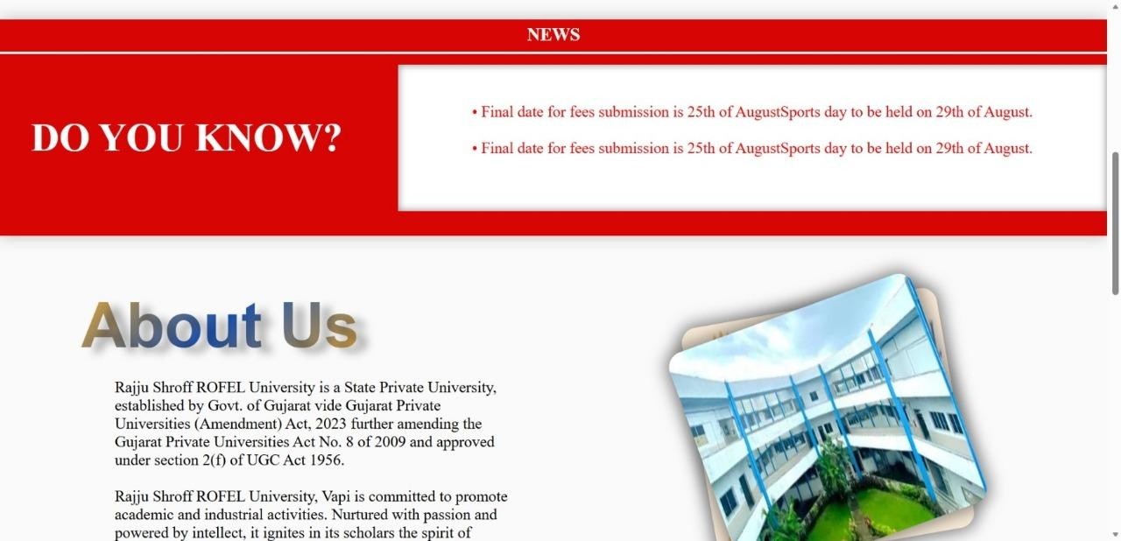
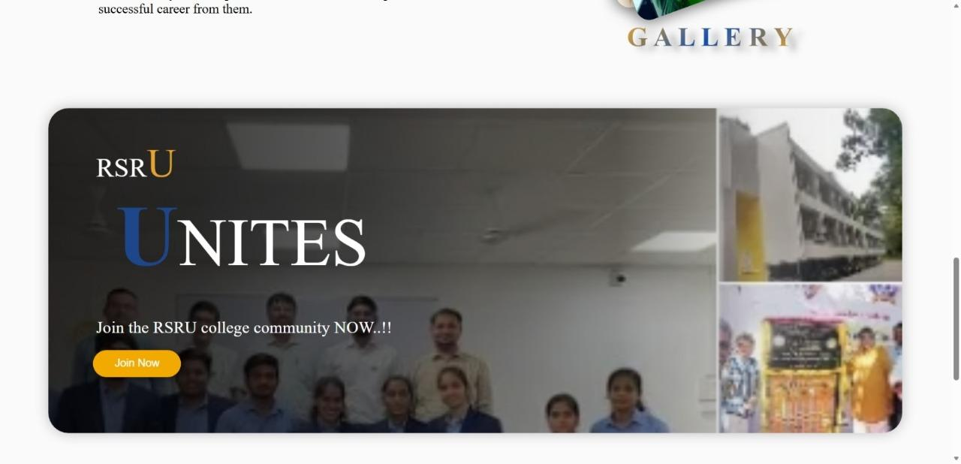 | 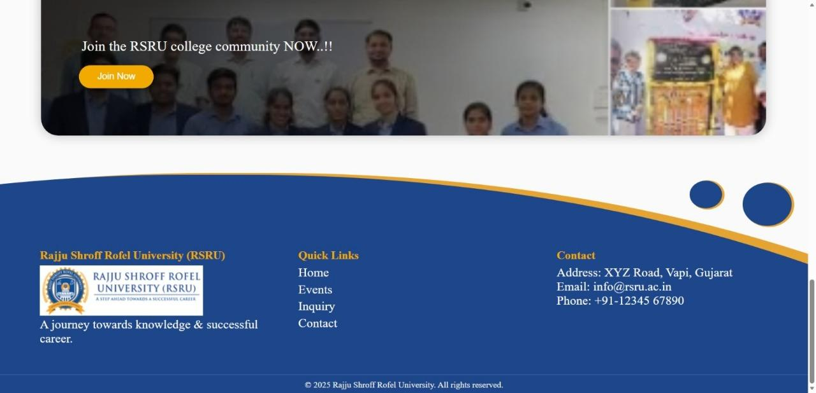

- Registration / Login

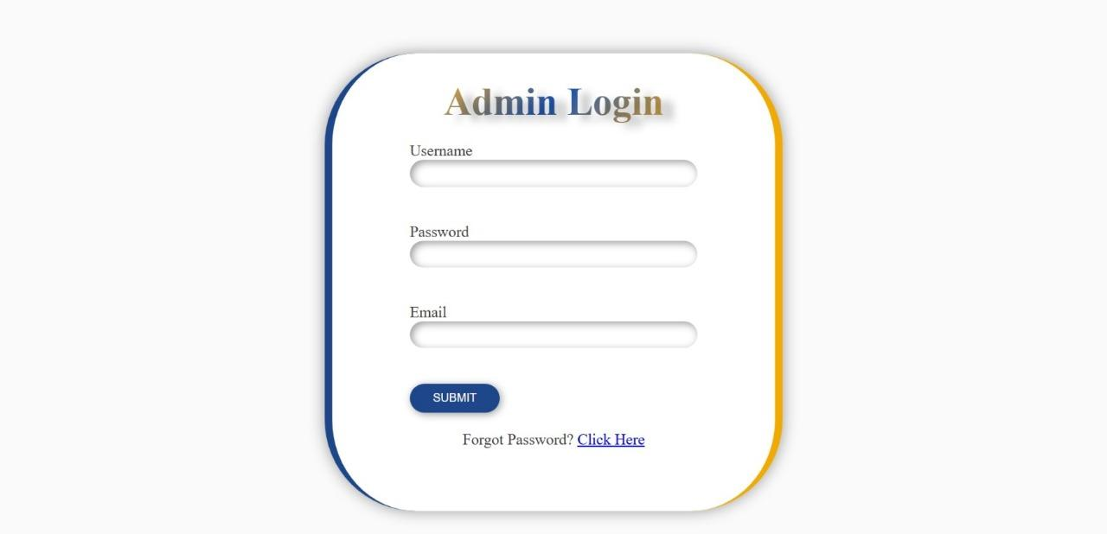 | 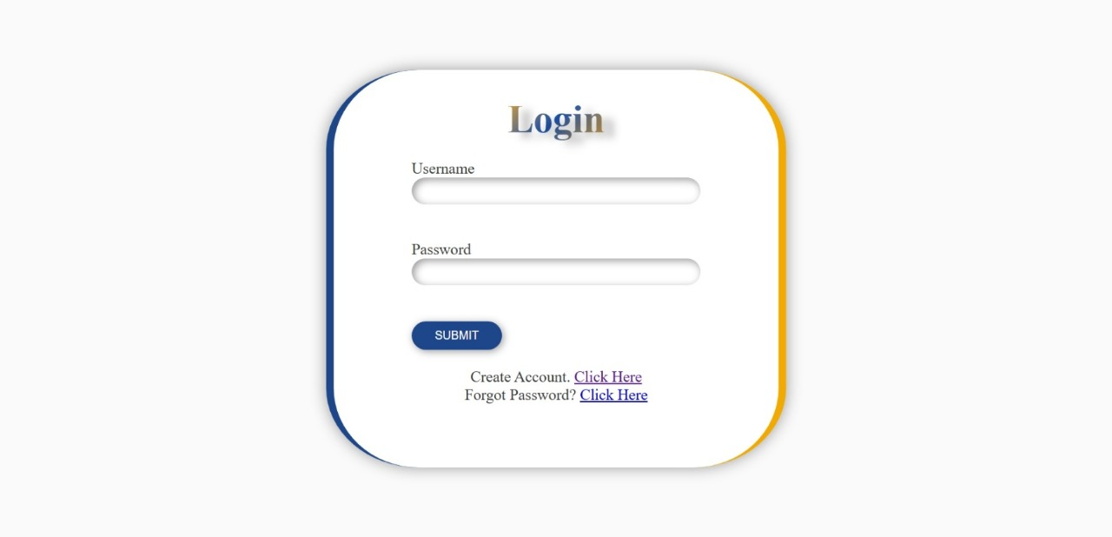
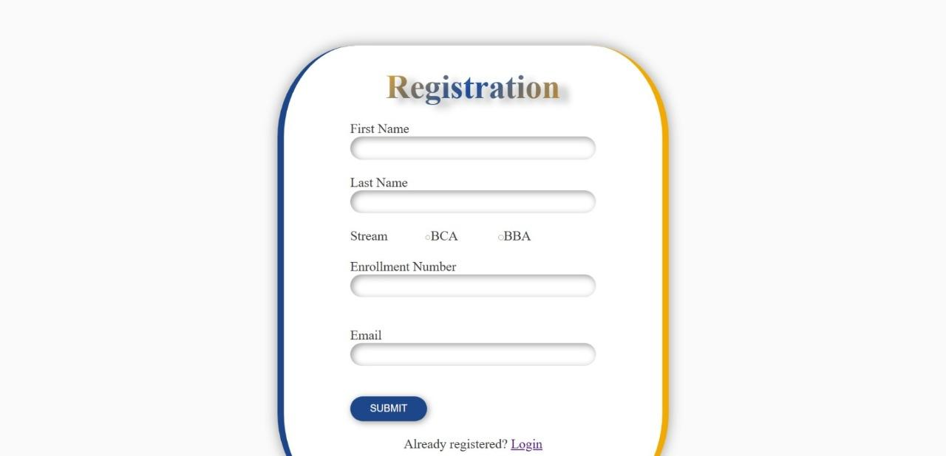 | 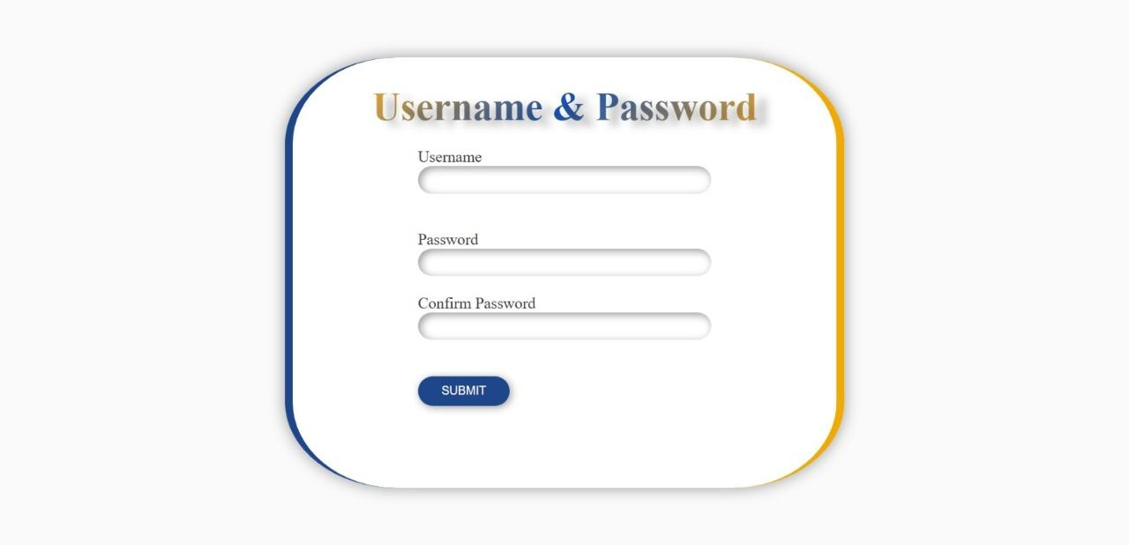

- Admin Panel

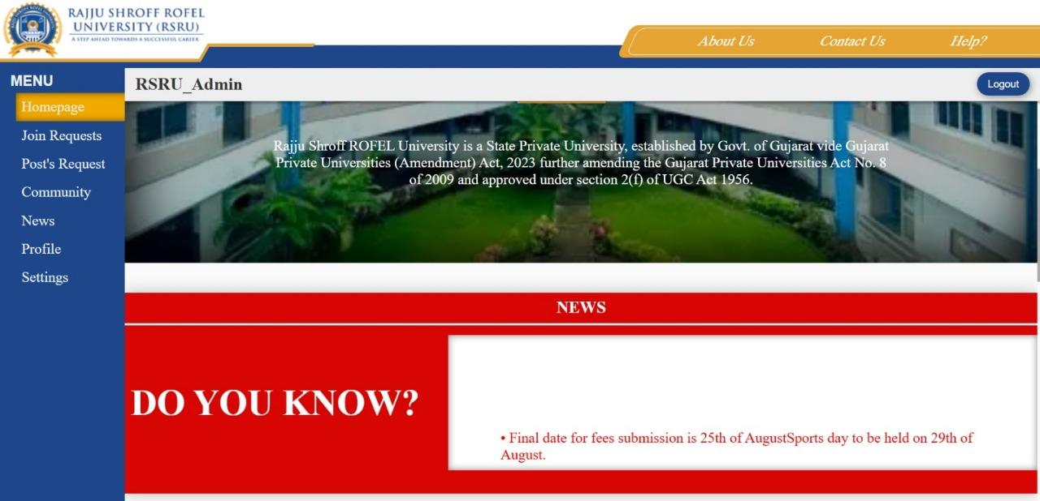 | 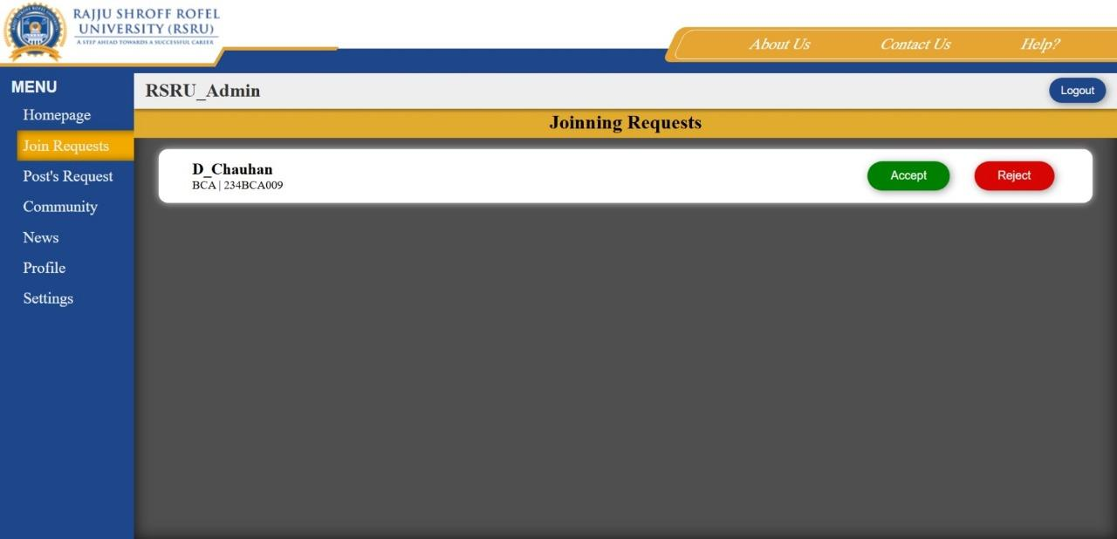
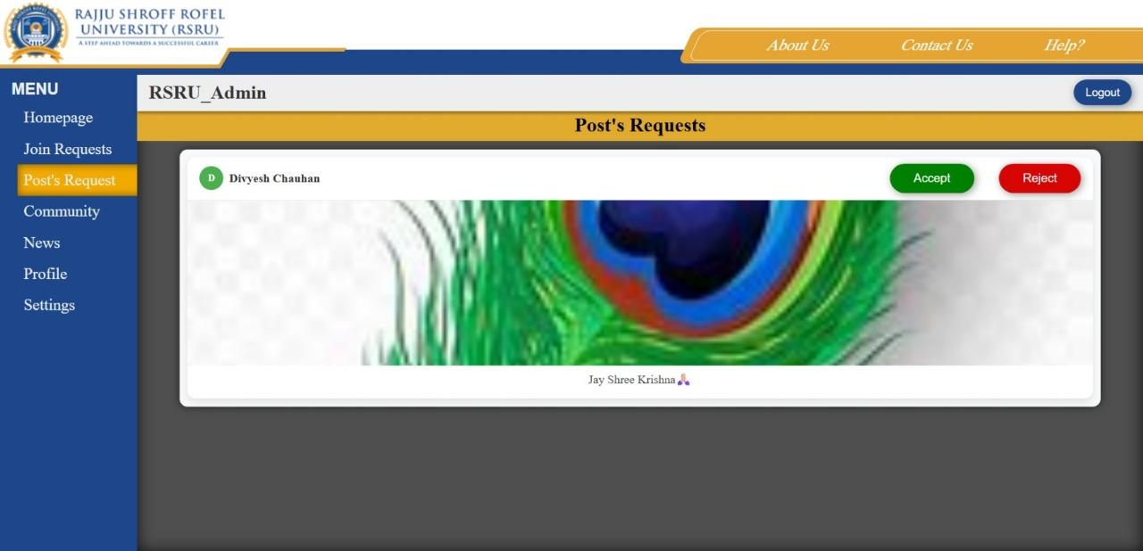 | 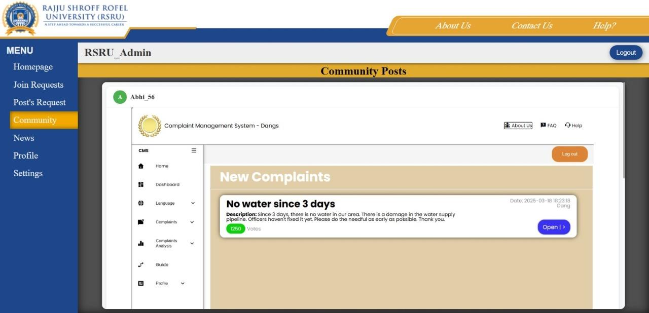
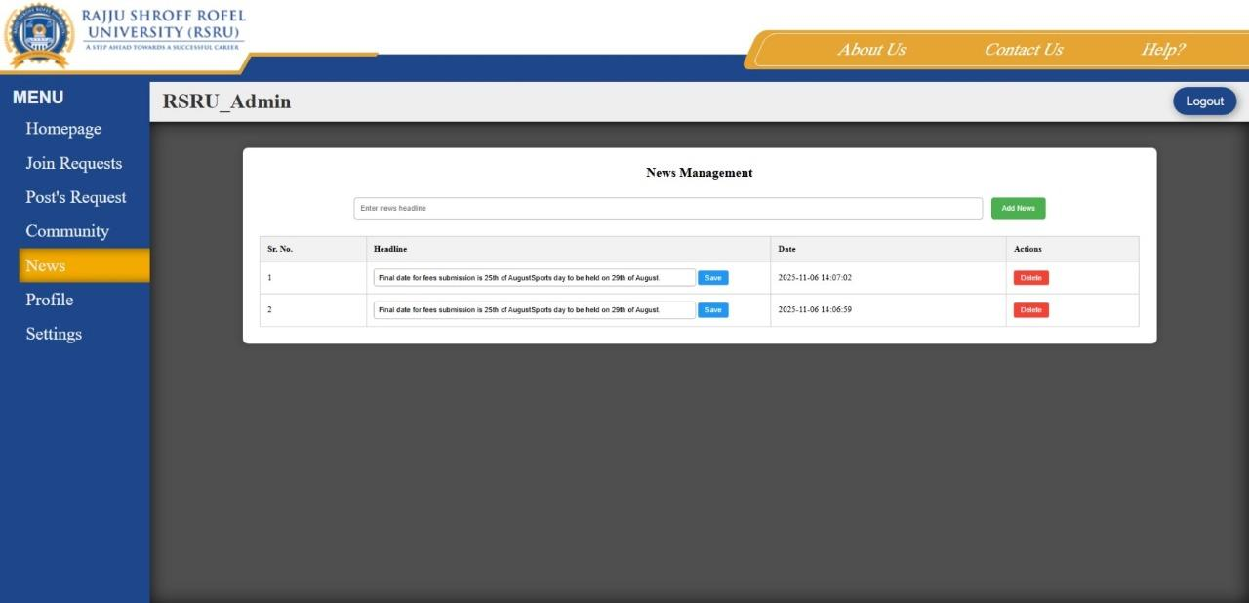

- User Panel

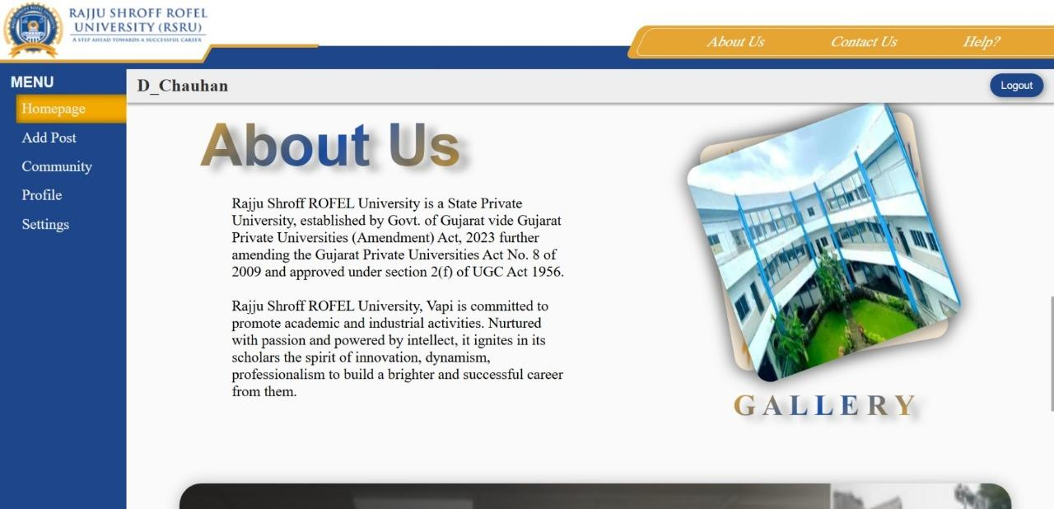 | 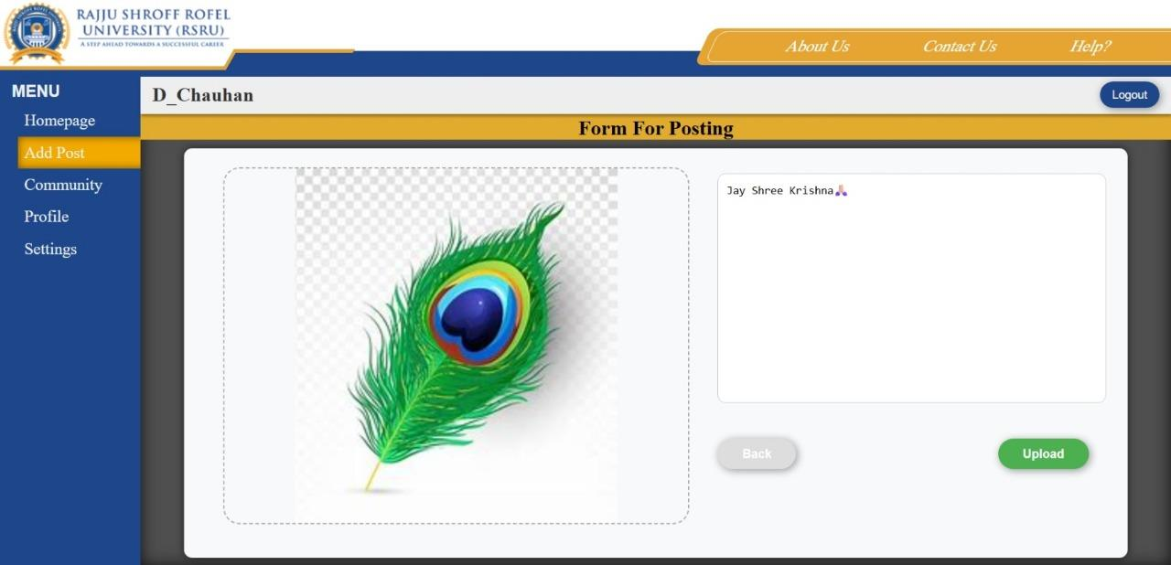
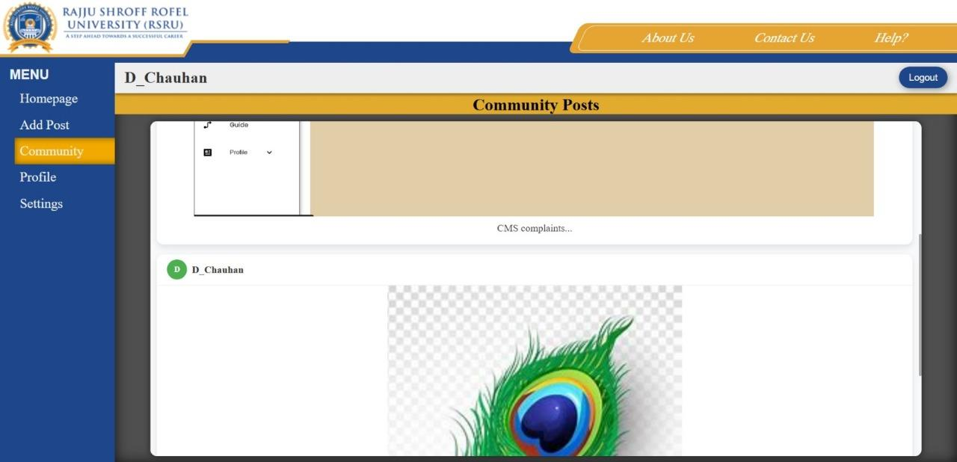

4. Bibliography / Webography

For successfully completing my project file I have taken help from the following website links:-

- www.chatgpt.com - code for sending email using xampp , for accepting images as input, for it’s preview before uploading and sometimes error identifying and debugging.

- www.draw.io - for making ER diagram and DFD.

- www.rofelbbabca.in - for reference and images.

- rsru.edu.in - for reference and images.

